Orange County Center for Contemporary Art

Subtopia March 2 – March 27th, 2005
Pamela Grau Twena, Dana Lovell and Jeffrey Koegel
Opening Reception: March 5th 6-10PM

Jeff Koegel makes textural, hard edge paintings that use elements of urban and domestic spaces as metaphor for technology and human emotion. Koegel¹suninhabited landscapes seem to float weightlessly in infinite space, like an uneasy dream suspended in stark clarity. In addition to the paintings – some on canvas, others on acetate - Koegel will mount 224 photographs of cheese sandwiches, a 20-month chronicle of surprisingly diverse and beautiful remains in ziplok pouches as returned from school by his young son. The aesthetic of the ziplok containment inspired Koegel to make a suite of transparent paintings on acetate.
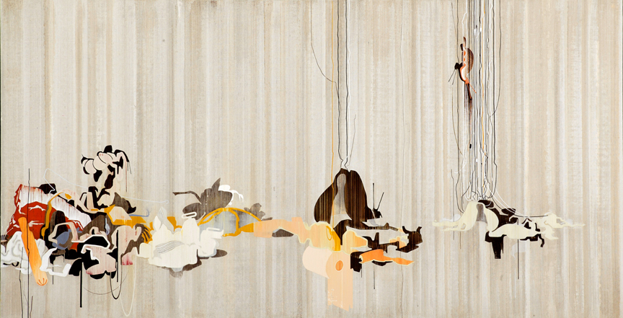

Pamela Grau Twena uses many medias: cast resins, clay, chalk, paint, wood, fire and plastic dolls to create figurative metaphors with which she plays out dialogues about identity, boundaries, perception, and surrender.
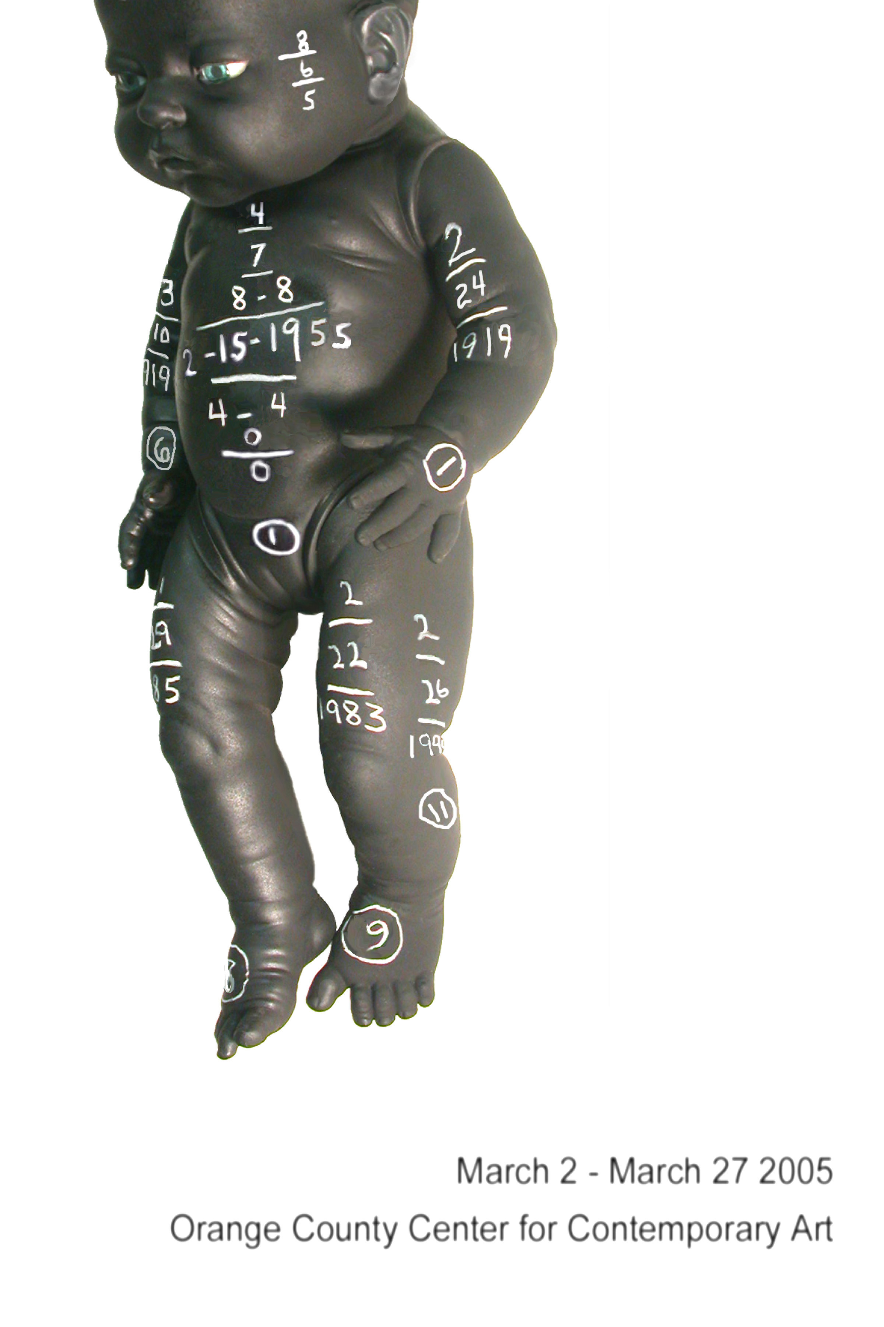

Orange County Center for Contemporary Art
117 N. Sycamore St. Santa Ana, CA 92701 714 667-1517
Please note our gallery hours are Tuesday through Sunday from 11am until 4pm.

Dana Collins Lovell
“The 36 Addresses Project” is the culmination of a two-year project that examines memory in a specific way. Dana Collins Lovell uses the computer to store and recall memory cues of some thirty-six addresses he has lived at in California. His migration includes residences from Orange County in the south to Humboldt County in the Pacific Northwest. The one-minute vignettes include family archival materials, in the form of old family photos, journals, and letters, appropriated film and television shows spanning the five decades covered in the piece as well as original video produced by the artist. Additionally, the artist will be showing paintings closely related to the video project, an installation of “memory mummies”, and doing a performance piece on March 19 at OCCCA. Lovell currently teaches at CSU Fullerton and is an active member of the Orange County Center for Contemporary Arts. 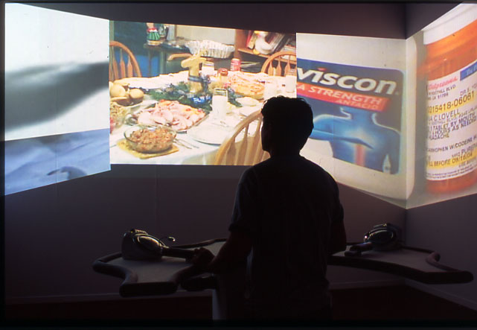
Photo by: Jeffrey Crussell

